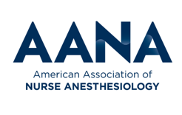
Award for Excellence in State Government Relations Advocacy
Nomination Form
Deadline for Submission: February 28

This award is given to a state association, not to an individual CRNA. Individual CRNAs may be nominated for the Ira Gunn Award.

Please Provide the Following Information:
Name of Individual, Organization or State Association Submitting Entry
Contact Name
Address

Address

Address

City, State Zip Code

Phone

Email Address

Winners will be informed of results during the AANA Mid-Year Assembly. It is imperative you provide information for a contact person who is attending the Mid-Year Assembly

Name
Cell Phone

Email Address

Hotel

Description of Government Relations Campaign or Activities:

In a brief narrative summary please discuss the following:

Objectives of the State Government Relations campaign/activities

Results of the State Government Relations (Contestants will not be judged on end results)

Timeline of the State Government Relations campaign/activities

Instructions:
- Please complete this entry form and email it to: State Government Affairs Division sga@aana.com
- Additional relevant materials, e.g., photos, etc. may be attached to the email with the application.
- APPLICATIONS NOT COMPLYING WITH INSTRUCTIONS AND FORMAT WILL NOT BE REVIEWED

